**Sri Lanka Institute of Information Technology**



**Data warehousing and Business Intelligence**

**Assignment 2**

**Student Registration No: IT20762186**

**Student Name: Gunasekara B.A.J.C.**

**Step 1 – Data Source for the Assignment**

I used data warehouse database (Football_Leagues_DW) as the data source which I created in Assignment 1. In there, is the fact table and dimensions as follows,

1. dbo.Factappearances
2. dbo.DimDate
3. dbo.Dimgames
4. dbo.Dimleagues
5. dbo.Dimplayers
6. dbo.Dimshots
7. dbo.Dimteamstats

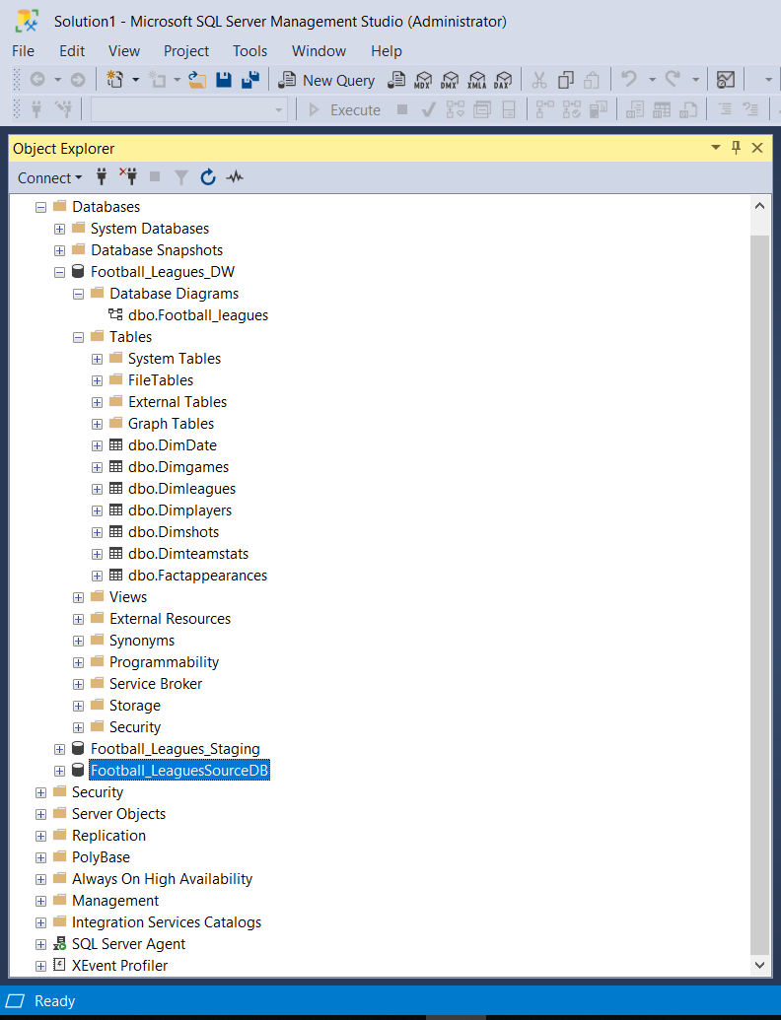Also, I used snowflake schema to integrate them. I used these data to create OLAP cubes and to generate OLAP operations in Excel and prepare reports in Report Builder.

**Following ER- diagram will describe the scenario of the selected dataset.**

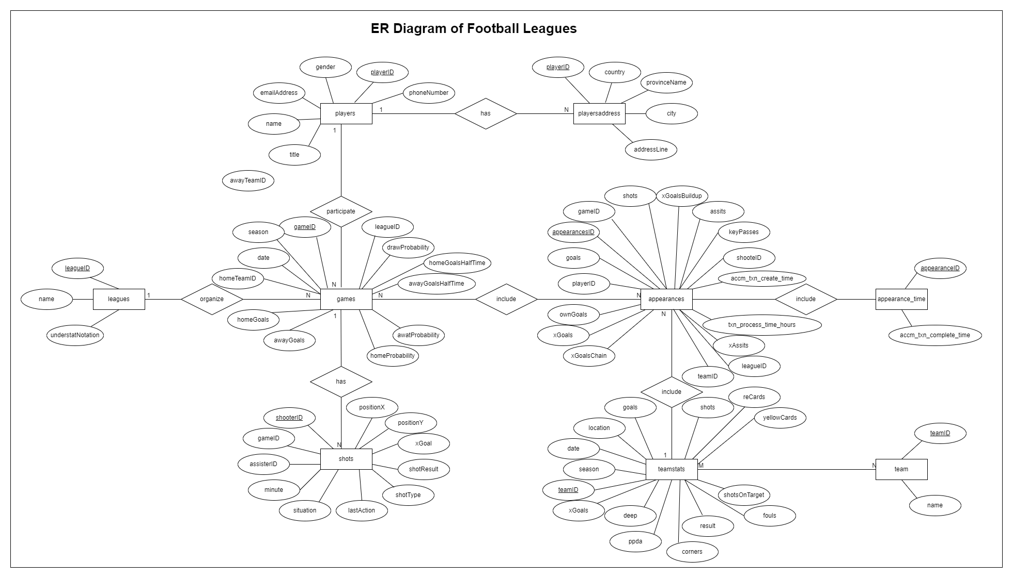

**Step 2 – SSAS Cube Implementation**

Used Tools: -

SSAS - SQL Server Analysis Service

SQL Server Management Studio

SSDT - SQL Server Data Tool

When creating the OLAP cubes first I created Analysis Services Multidimensional and Data Mining Project on SSDT.

Then I renamed it as “SSASAssignment2_DWBI”. Then we can see folder structure as follow,

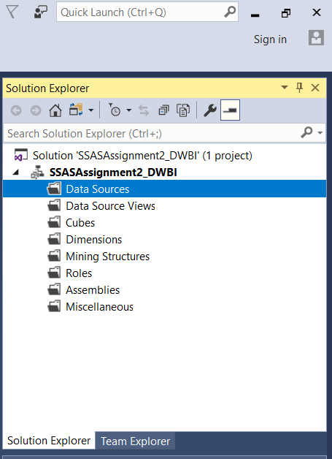

Then the following steps are done,

1. **Create a Data source**

Under the Data Sources folder in above folder structure, and a new Data Source to create connection with my Football_Leagues_DW is added and renamed as DS_ Football_Leagues_DW .I used windows login credentials to connect it.

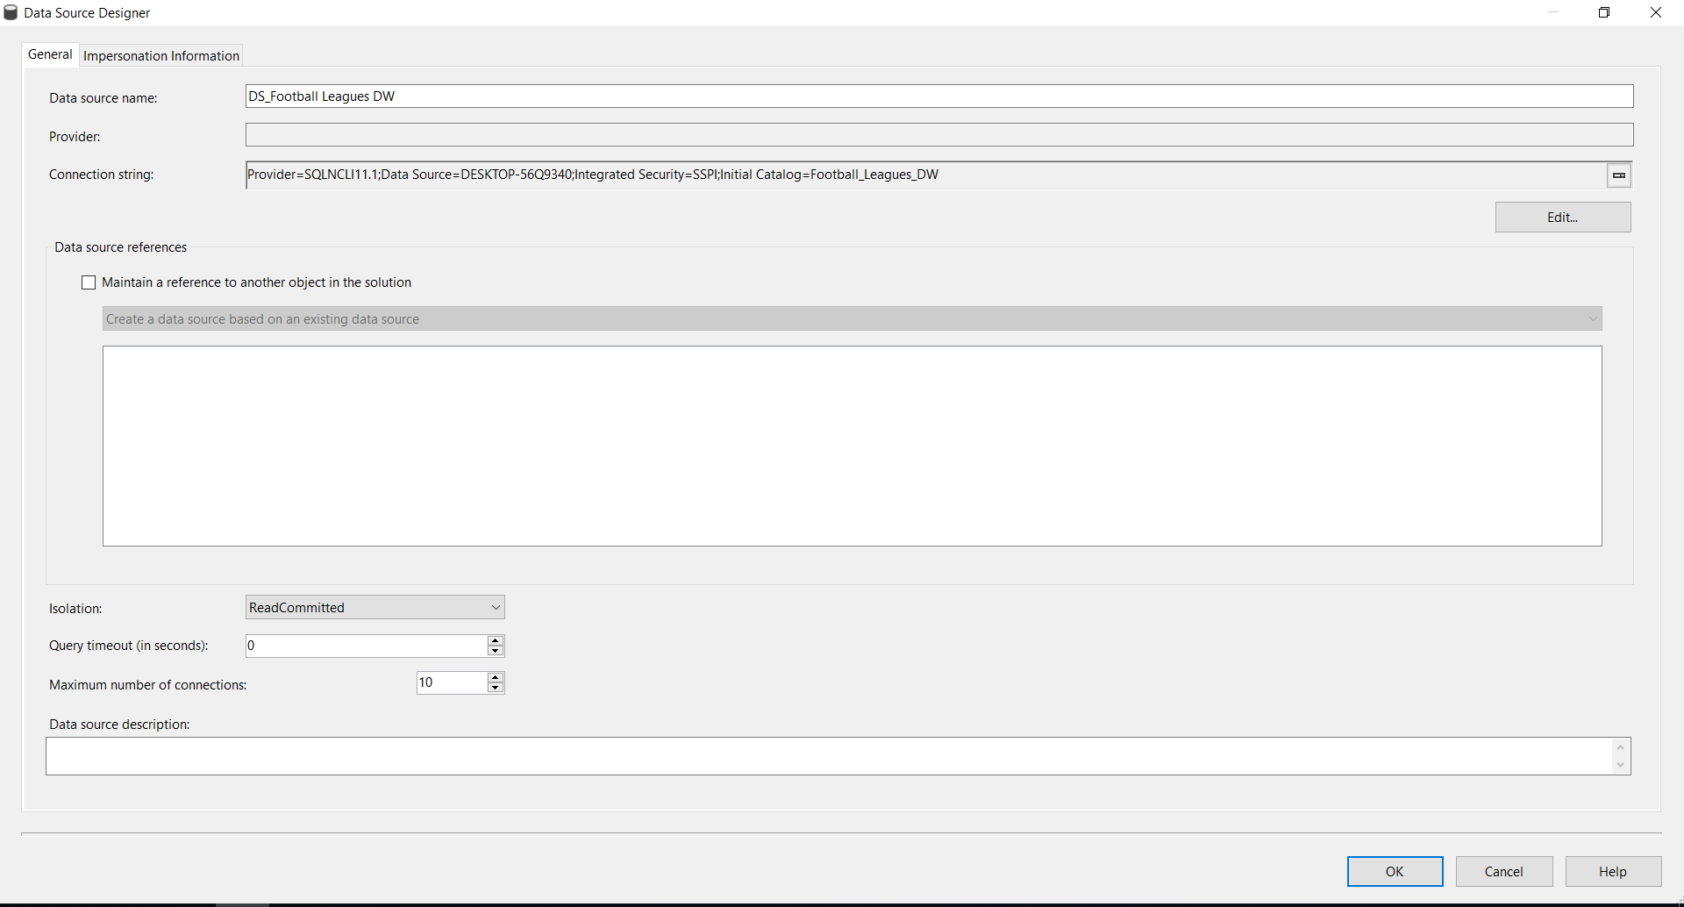

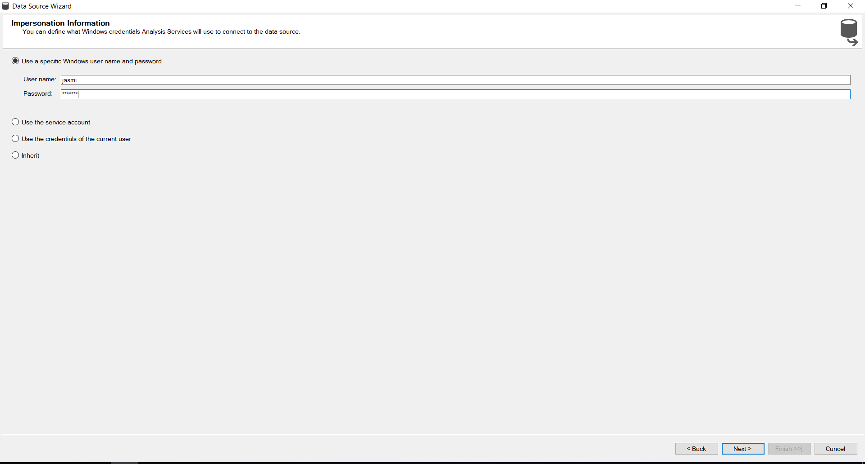

1. **Create a Data Source View**

Under the Data Source Views folder, I added new data source view called DSV_Football_Leagues _DW.

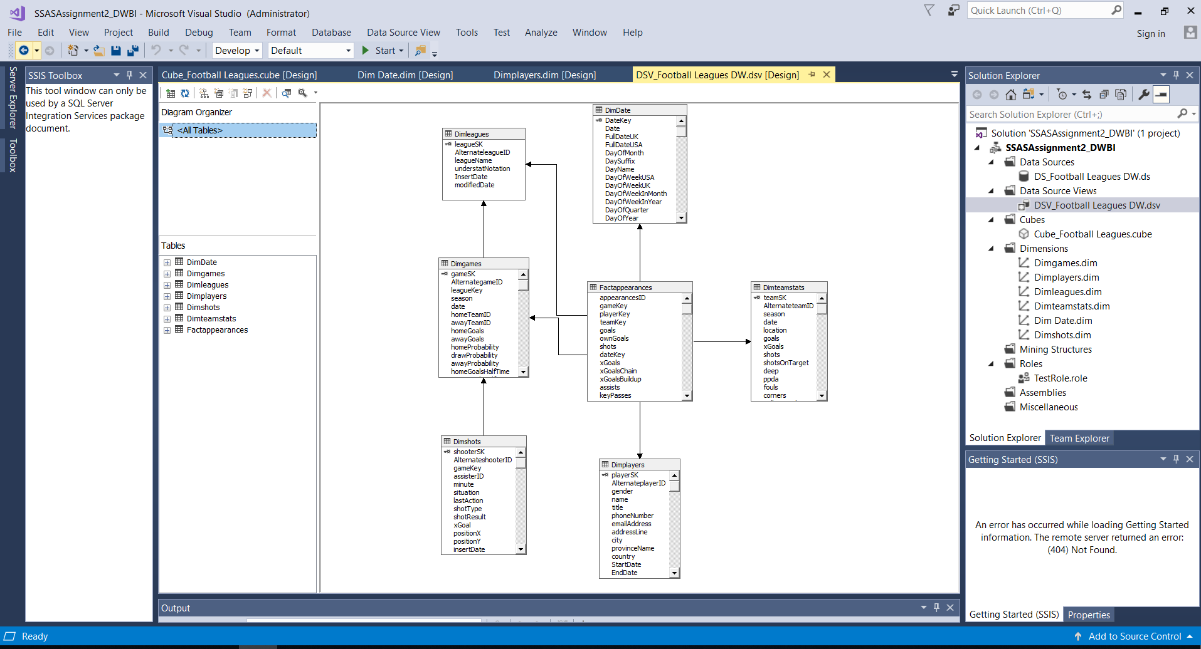

1. **Create a Cube**

Under the Cubes folder I created new cube using above data source view called Cube_Football_Leagues.

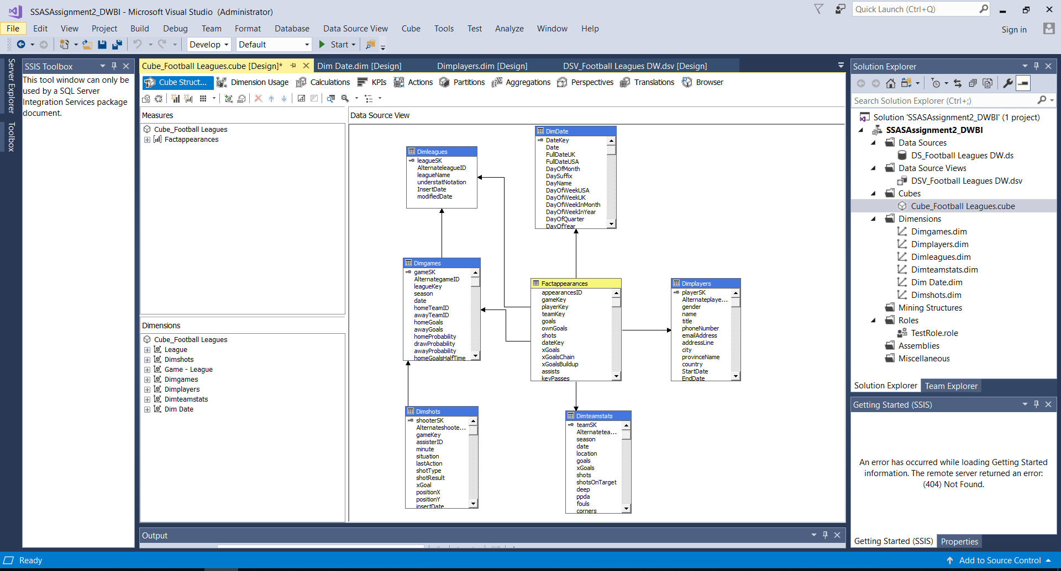

Then I added attributes to all dimensions and created hierarchy to relevant dimensions.

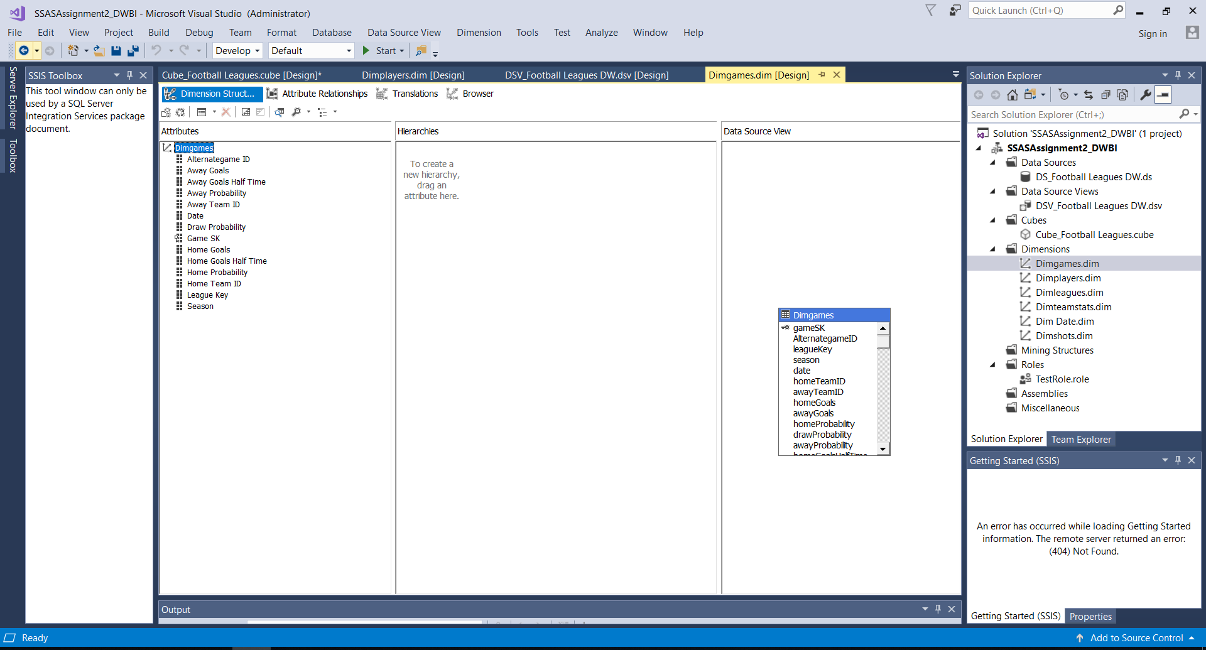

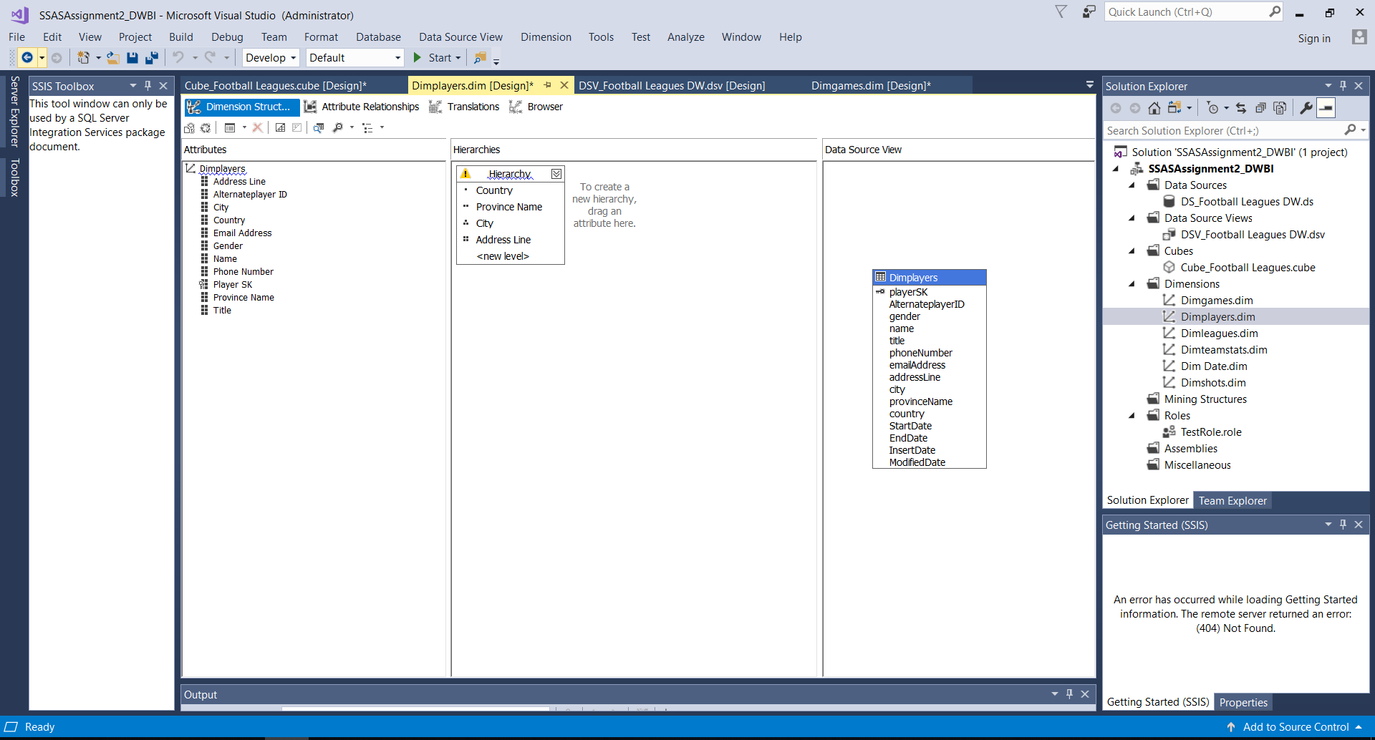

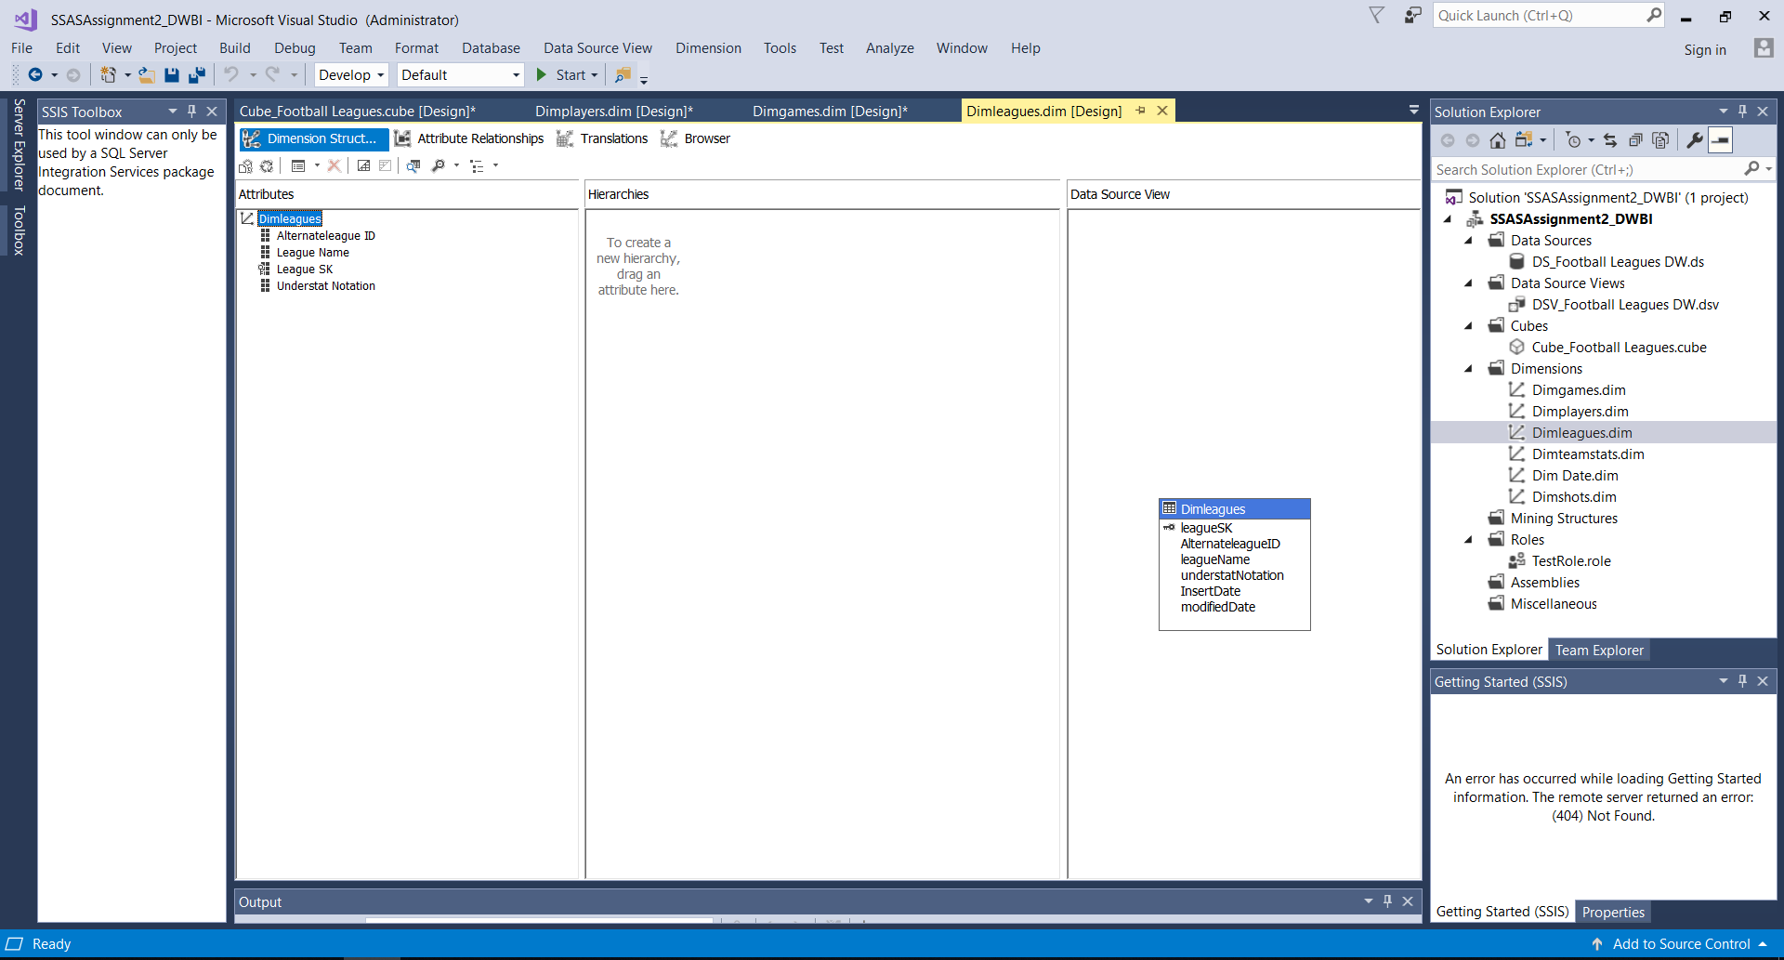

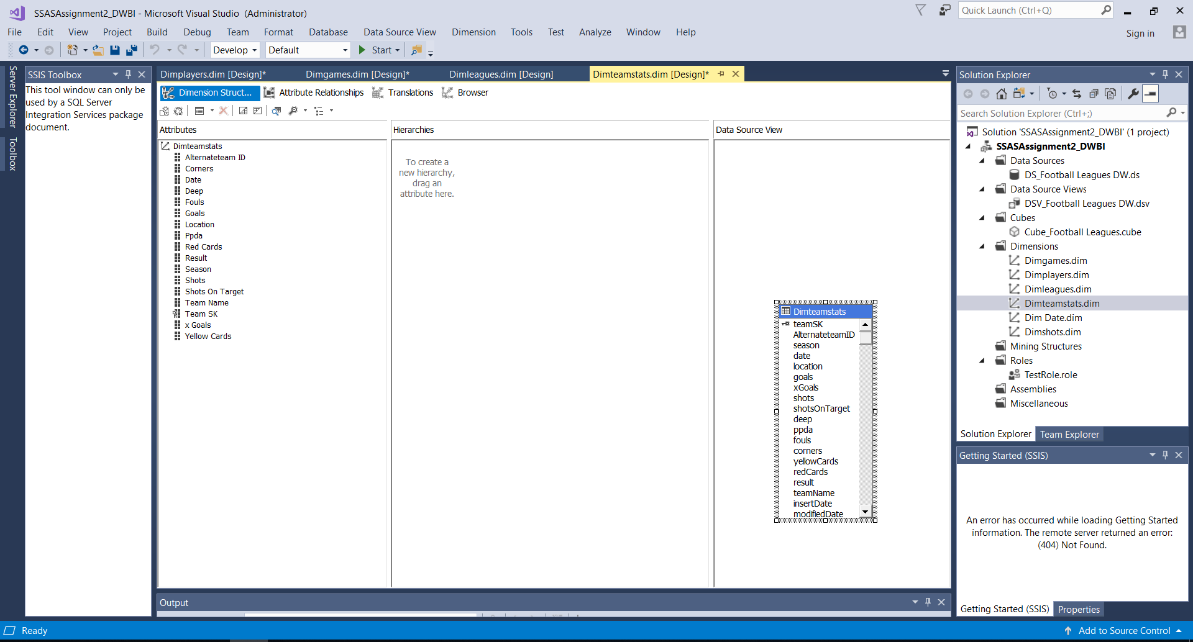

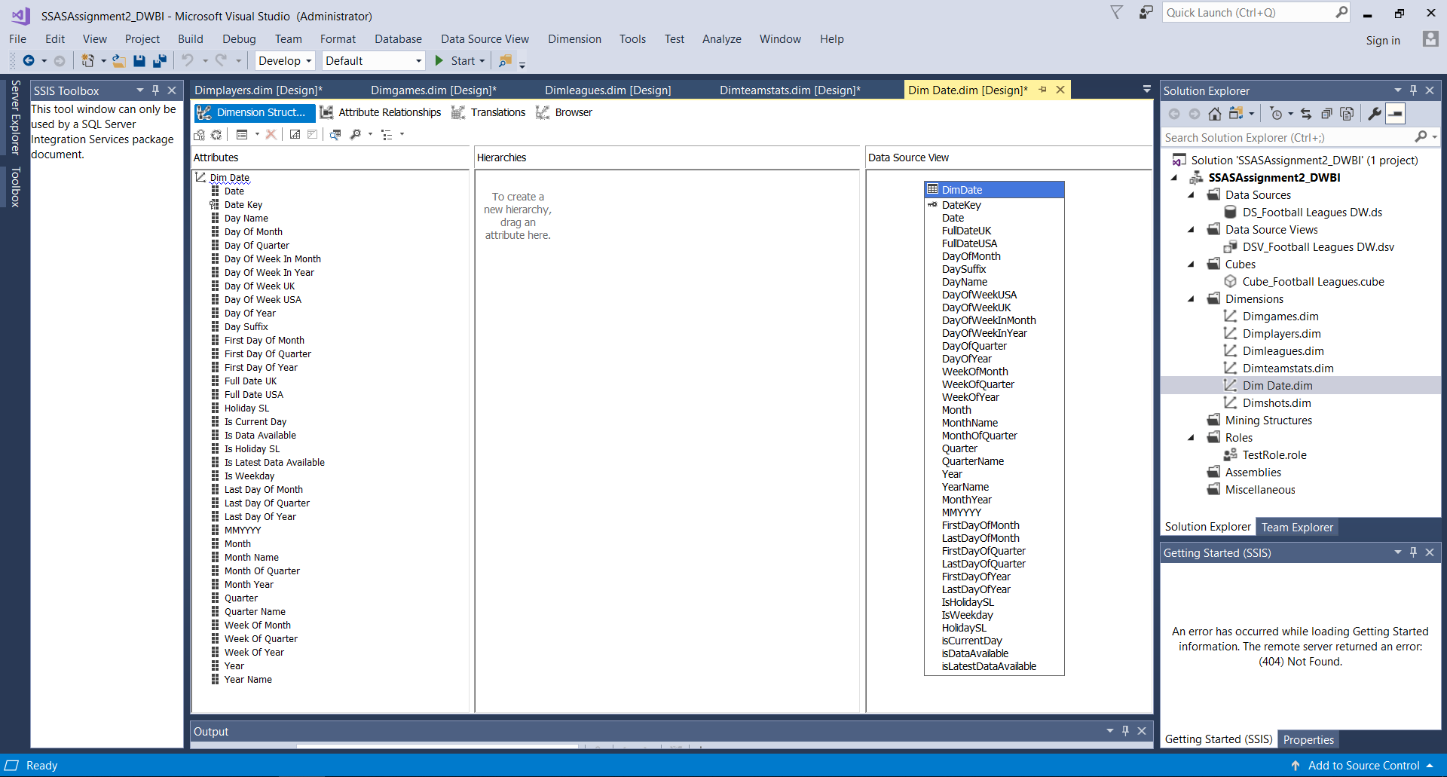

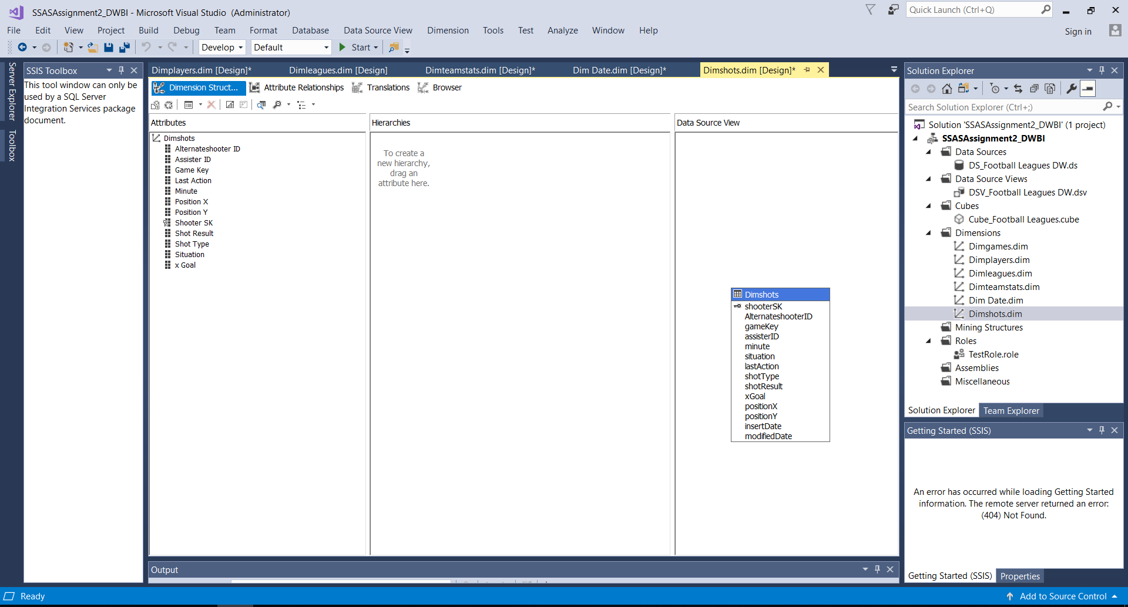

These are the 2 hierarchies that was created,

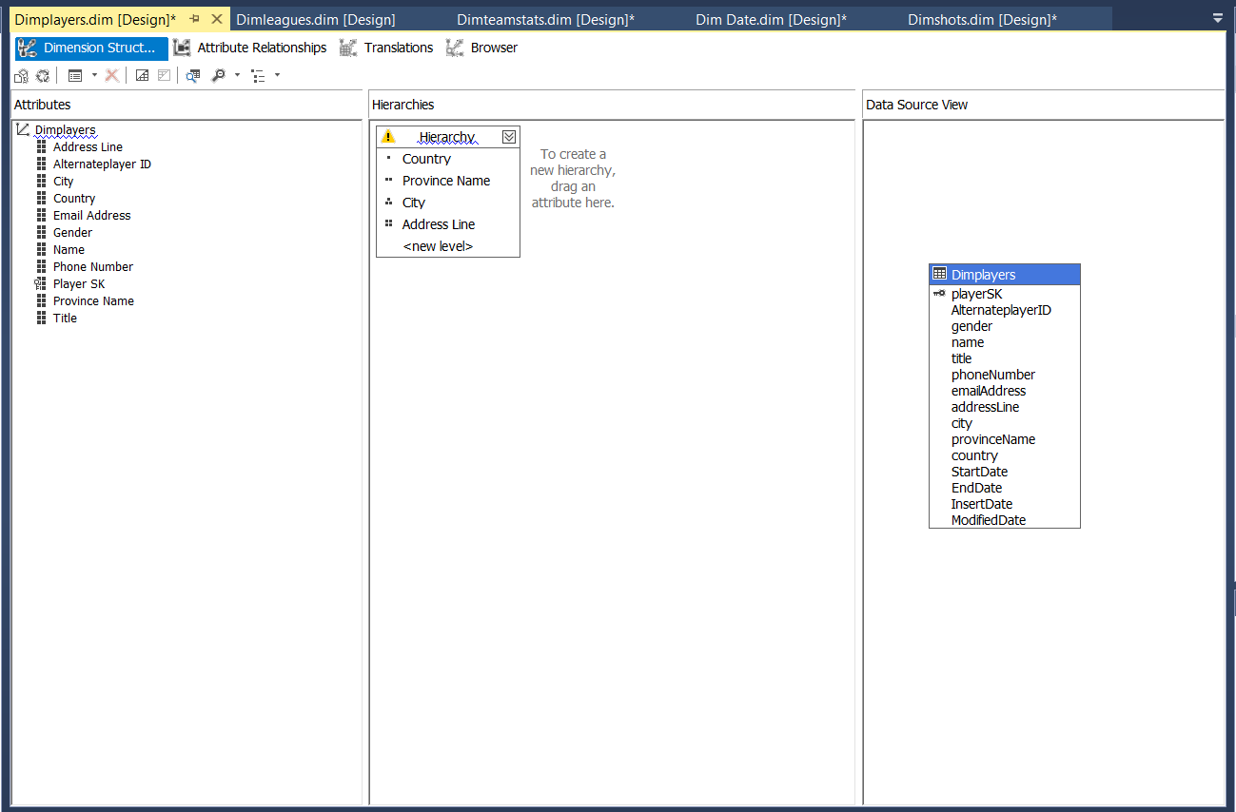

After been deployed folder structure is shown as below,

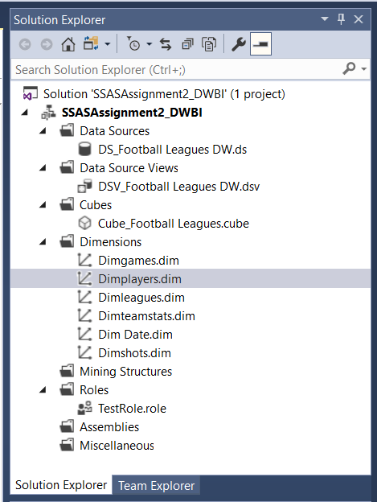

1. **Process the Cube**

After finishing all the above steps, the cube is processed. If it is successfully processed a message is displayed signifying process succeeded as shown below.

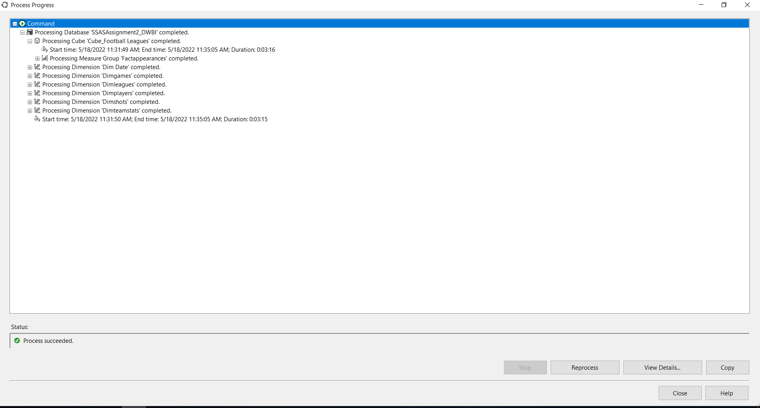

1. **Deploy the Cube**

After finishing the process step, the cube is deployed. If it is successfully deployed a message is displayed signifying Deployment Completed Successfully as shown below.

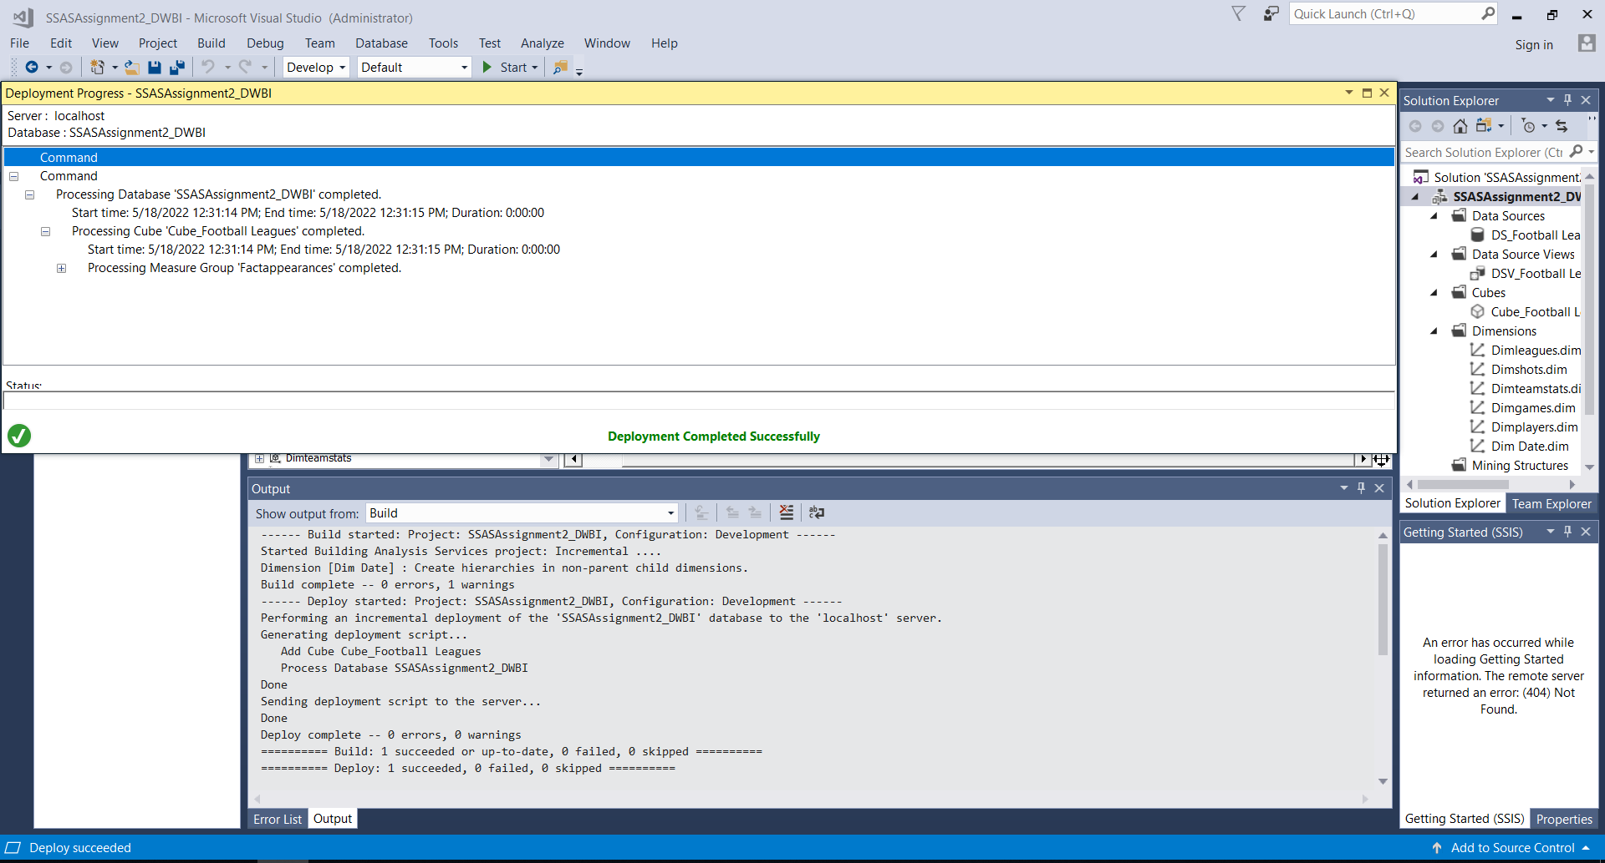

1. **Create KPI**

KPIs are developed based on the needs of the organization. It is a measurable value that shows how well an organization accomplishes essential business objectives. KPIs are used by businesses to assess their progress toward achieving their objectives.

Following Figure shows the KPI which I created after the deploying cube. These are the KPI values which created for Appearances. It can be used for determining how much of expected goals took more than 0.

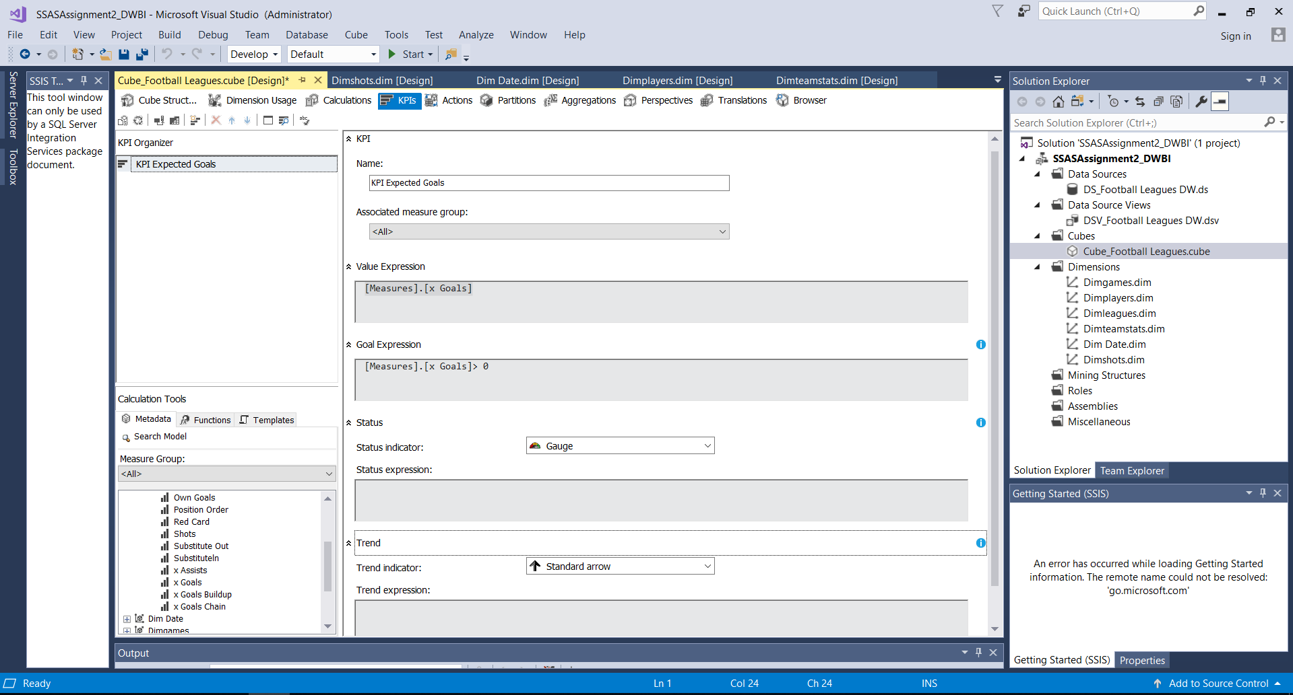

1. **Browse Cube Data**

Browsing data is done via using SSMS. By connecting SSAS to SSMS using instance and MDX queries can generated by selecting the relevant fields from the dimensions.

When browsing cube data, a KPI value or measurement value is compulsory .Otherwise it will not be executed.

Below figure shows how to browse data in SSMS,

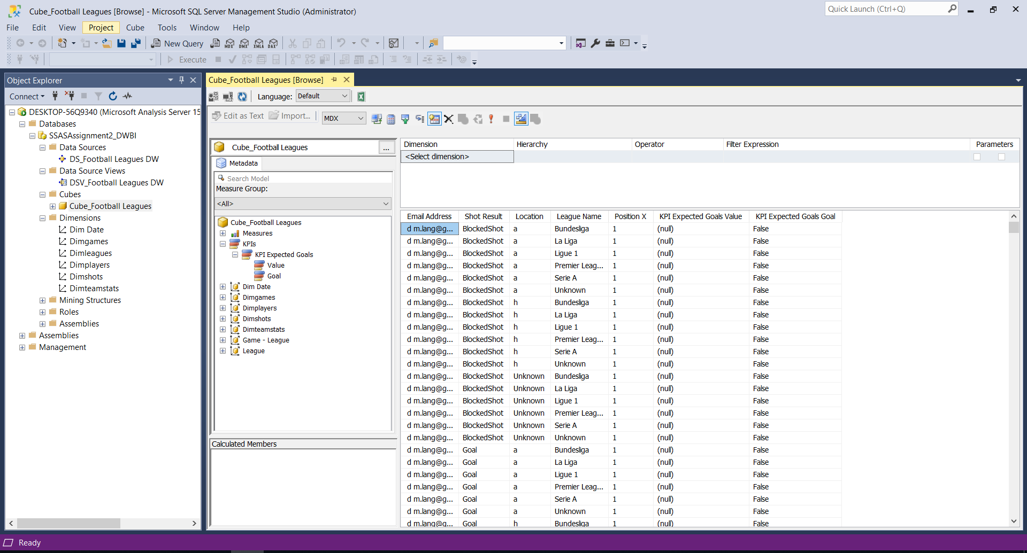

**Step 3 – Demonstration of OLAP Operations**

Used Tools:-

Microsoft Excel

SQL Server Management Studio

SSAS – SQL Server Analysis Services

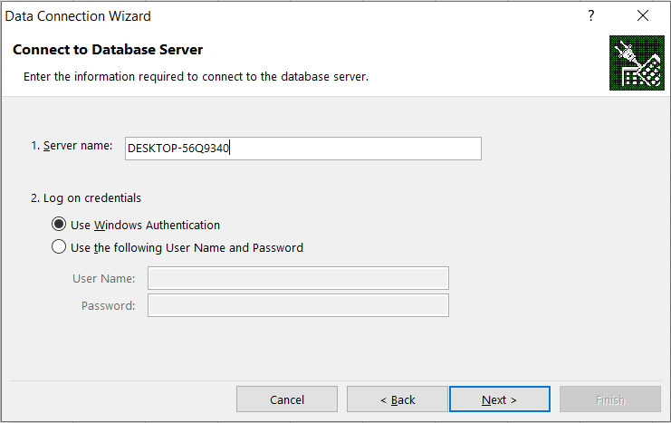To display the OLAP operation first, the Excel to SSAS Cube without using MDX queries. In this way, I connected with the whole set of fact and dimension tables. And below picture show how to connect the Excel to SSAS Cube successfully.

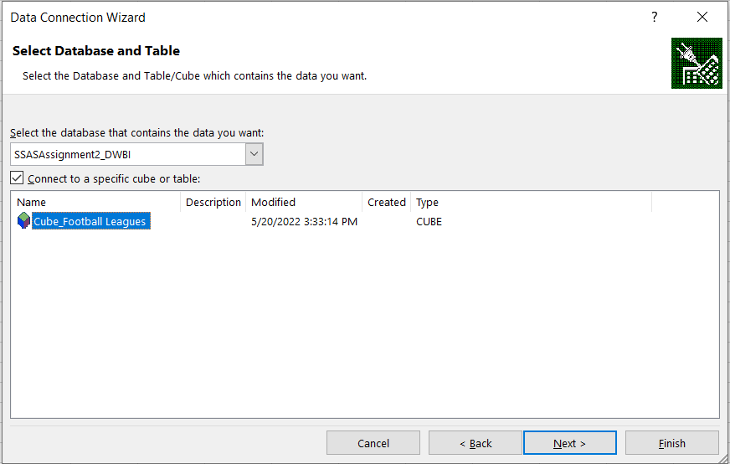

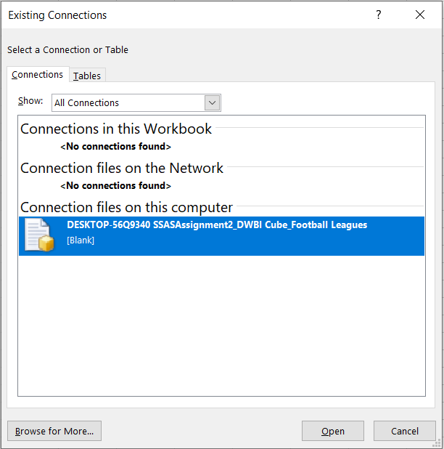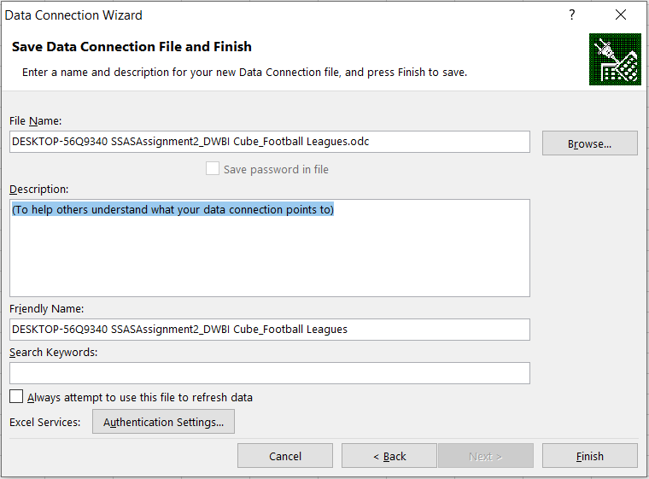

1. **Roll-up**

Climbing up a hierarchy of a dimension to aggregate data is what the Roll up OLAP function in cubes signifies.

In this following excel sheet shows shots of the appearances.

I have included a hierarchy (Country→ Province Name → City → Address Line→ playerID) below chart shows the patient’s address details climbing up from a lower stage to higher stage.

In the graph I showed the sum of sots.

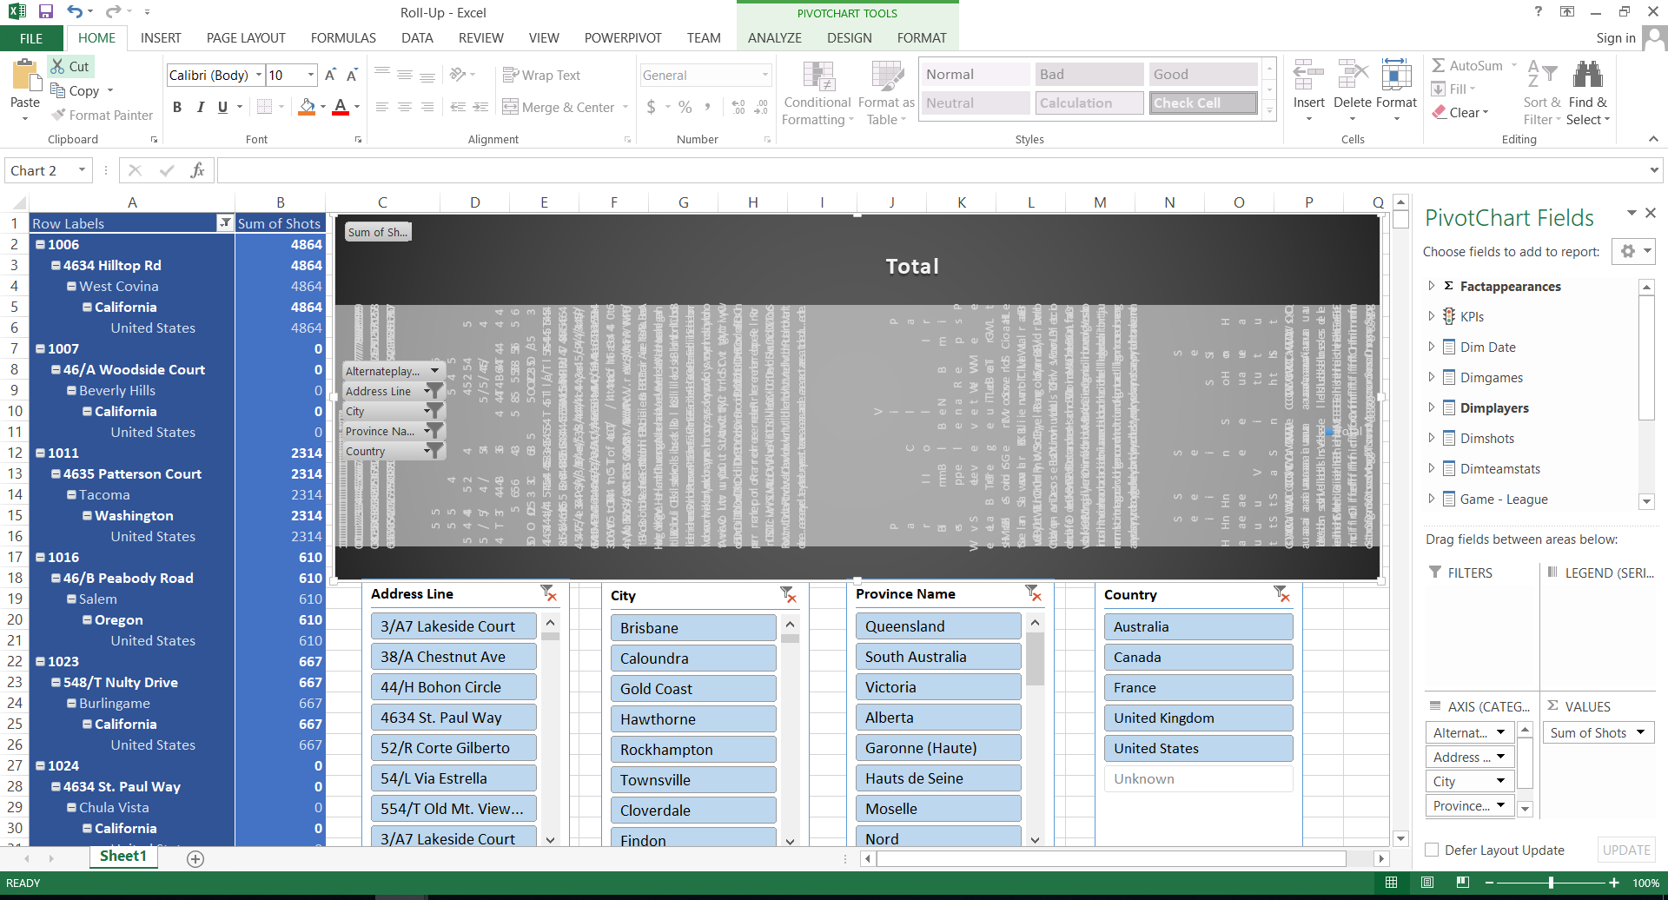

1. **Drill-Down**

In cubes, the drill down OLAP function entails navigating through details by moving down a hierarchy of a dimension.

Following Figure shows country can be drilled down to province name and province name can be drilled down to cities, then cities can be drilled down to address line and from that we can find relevant playerID.

So, we can view the sum of xGoals player wise. This process is the opposite of the roll up operation.

And the graph shows country wise sum of xGoals.

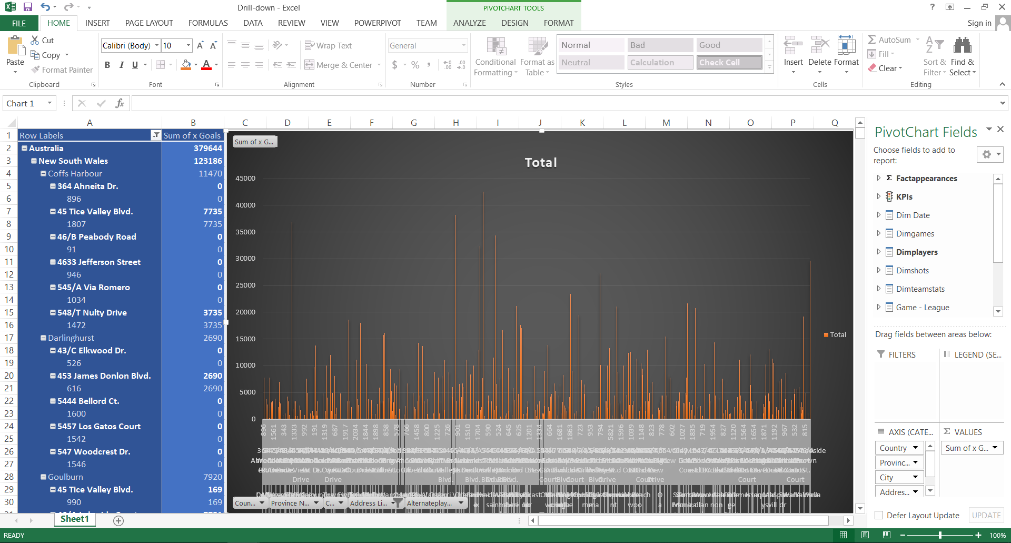

1. **Slice**

Slices are visual filters that can be used to filter data in a pivot table or chart. For the pivot table and pivot chart, I utilized two slices, one for each.

The slices I used to filter my pivot table and pivot chart are shown in the diagram below.

In this excel sheet I added the slicers on Month, when I clicked the Month, I can get the sum of xGoals, sum of xGoals Chain and sum of xGoals Build up according of the selected year. Also, I select more than one year and get details from multiple selections.

And the chart showed month-wise, sum of xGoals, sum of xGoals Chain and sum of xGoals Build up.

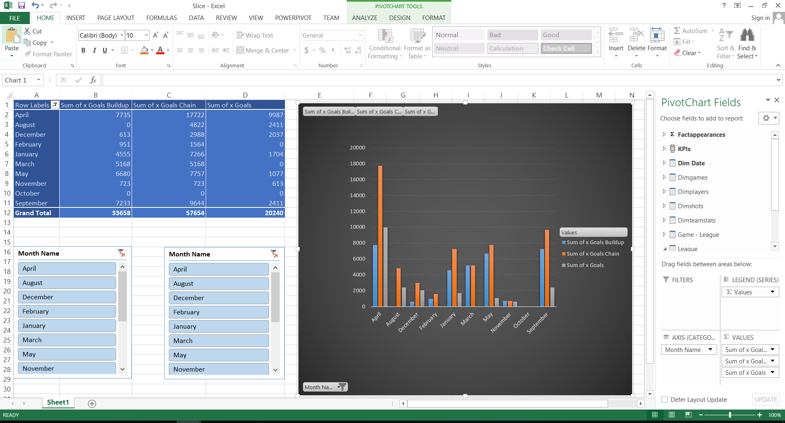

1. **Dice**

Selecting appropriate qualities to group the data by is referred to as dicing the data.

To analyze the data in the pivot table and pivot chart, I utilized two slicers. Those are teamstats slicer and appearances slicer. Then, I grouped data according to team name and xGoals.

After that, I can get goals-wise xGoals count of teams according to team name. And the graph show team name-wise count of xGoals has taken.

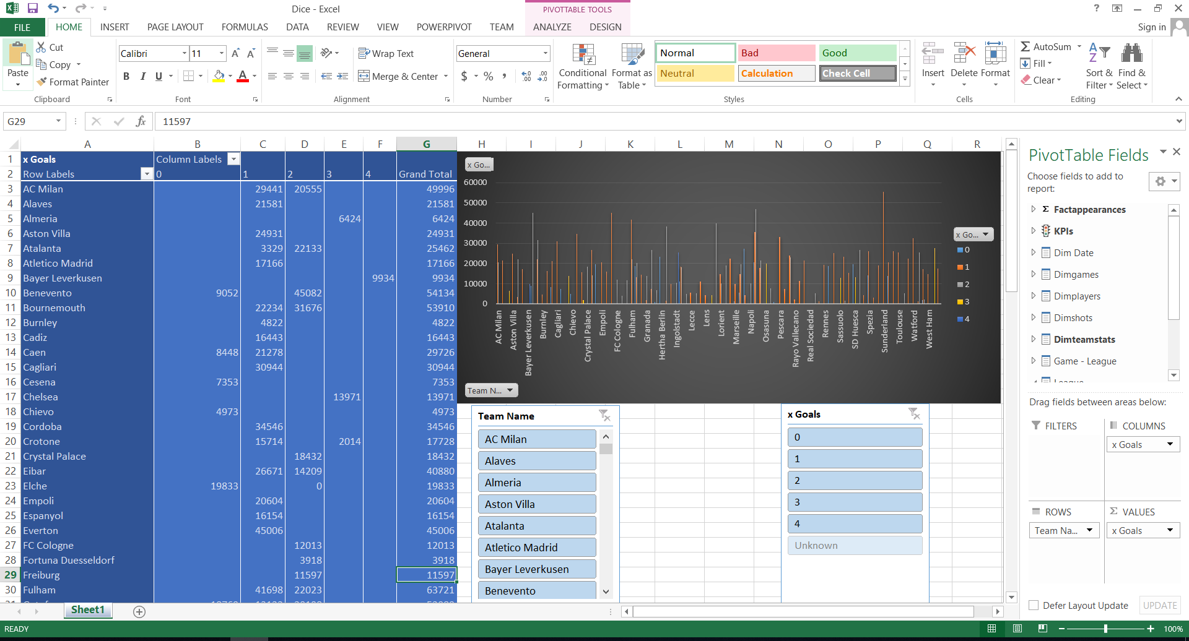

1. **Pivot**

A PivotTable is a useful tool for summarizing, analyzing, exploring, and presenting data in a visual format. Pivot Charts offer visualizations to the summary data in a PivotTable, making them more useful.

Here I used pivot table and pivot chart to display the players expected goals of year wise.

The graph shows xGoals count of players name according to the year.

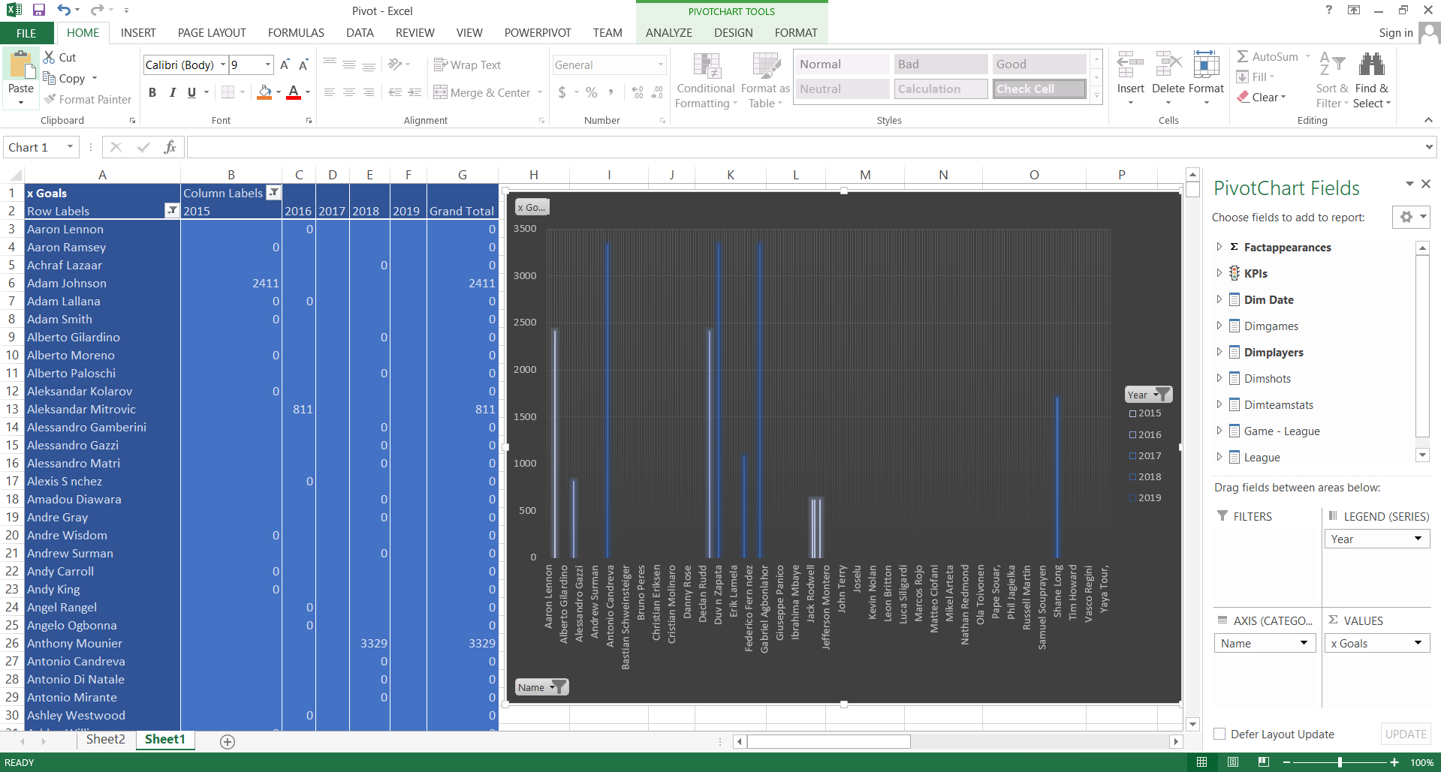

**Step 4 – SSRS Reports**

Used Tools:-

Report Builder

SSRS web portal

Reporting Service Configuration Manager

SQL Server Management Studio

Report Server database

SQL Server Reporting Services

Below figure show the web portal view. In there, the created paginated reports and SSRS folder is displayed.

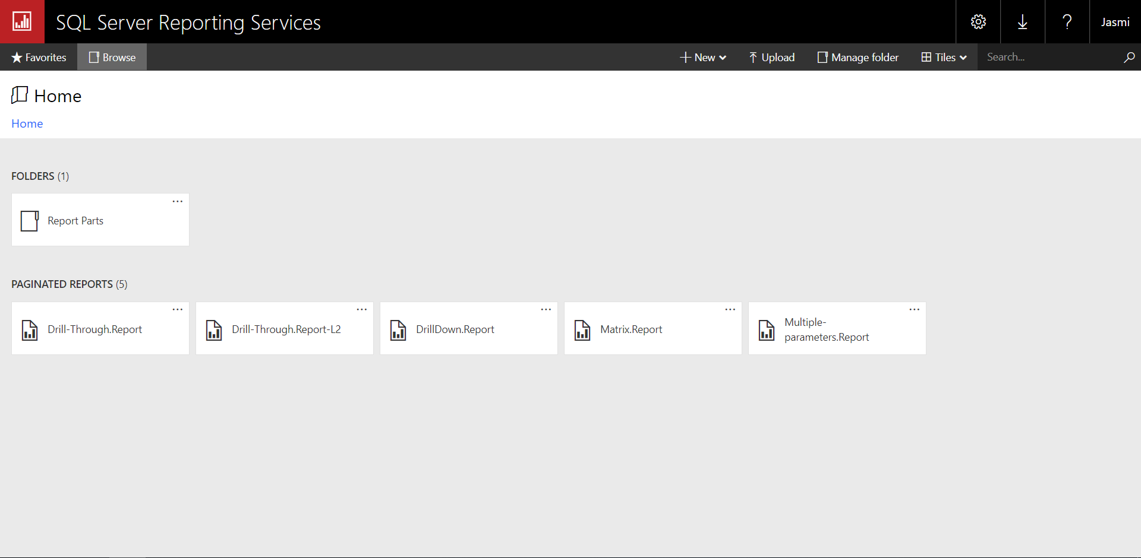

This is the main structure of the SSRS in Report Builder.

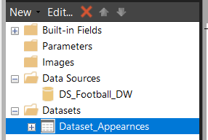

1. **Report 1 : Report with a matrix**

This is the structure of the SSRS in Report Builder in report with a matrix. My SSRS project is named as Matrix.Report and the created report can be seen as the figure.

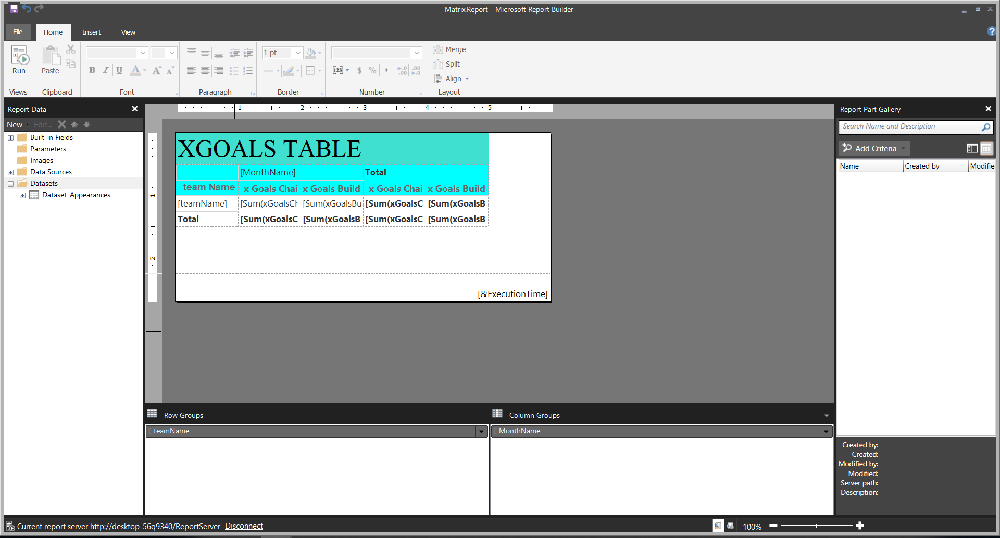

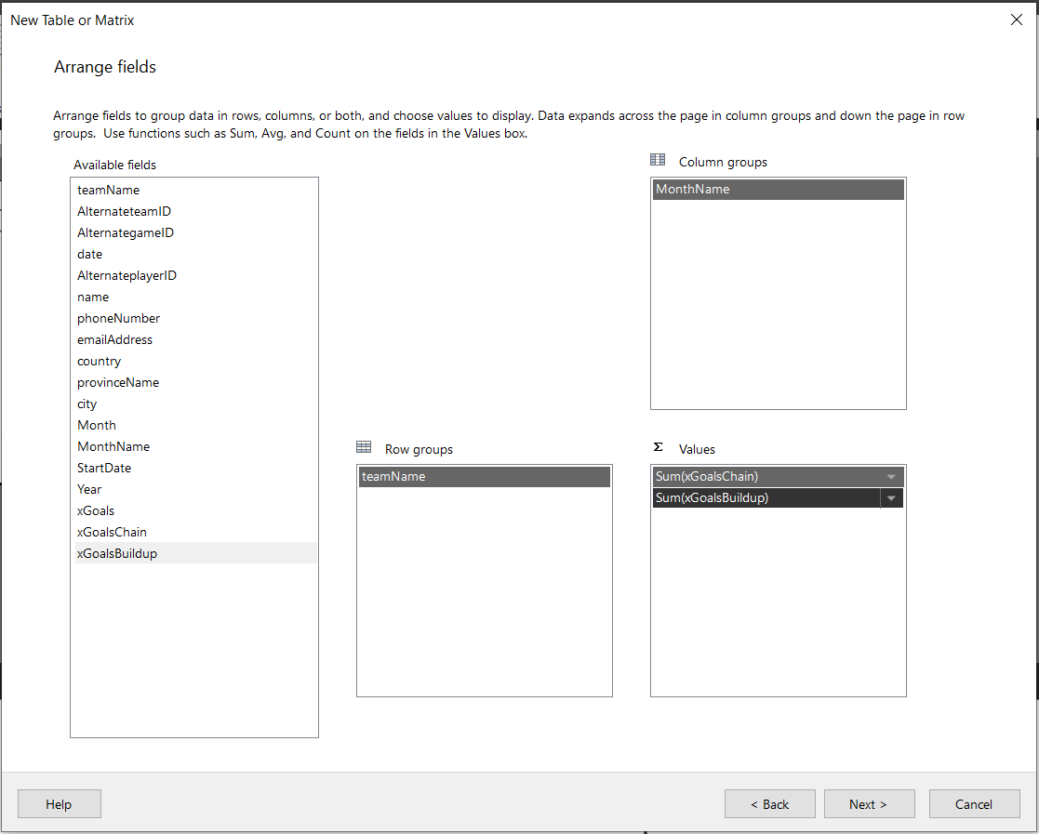Below figure shows how to add columns according to the report,

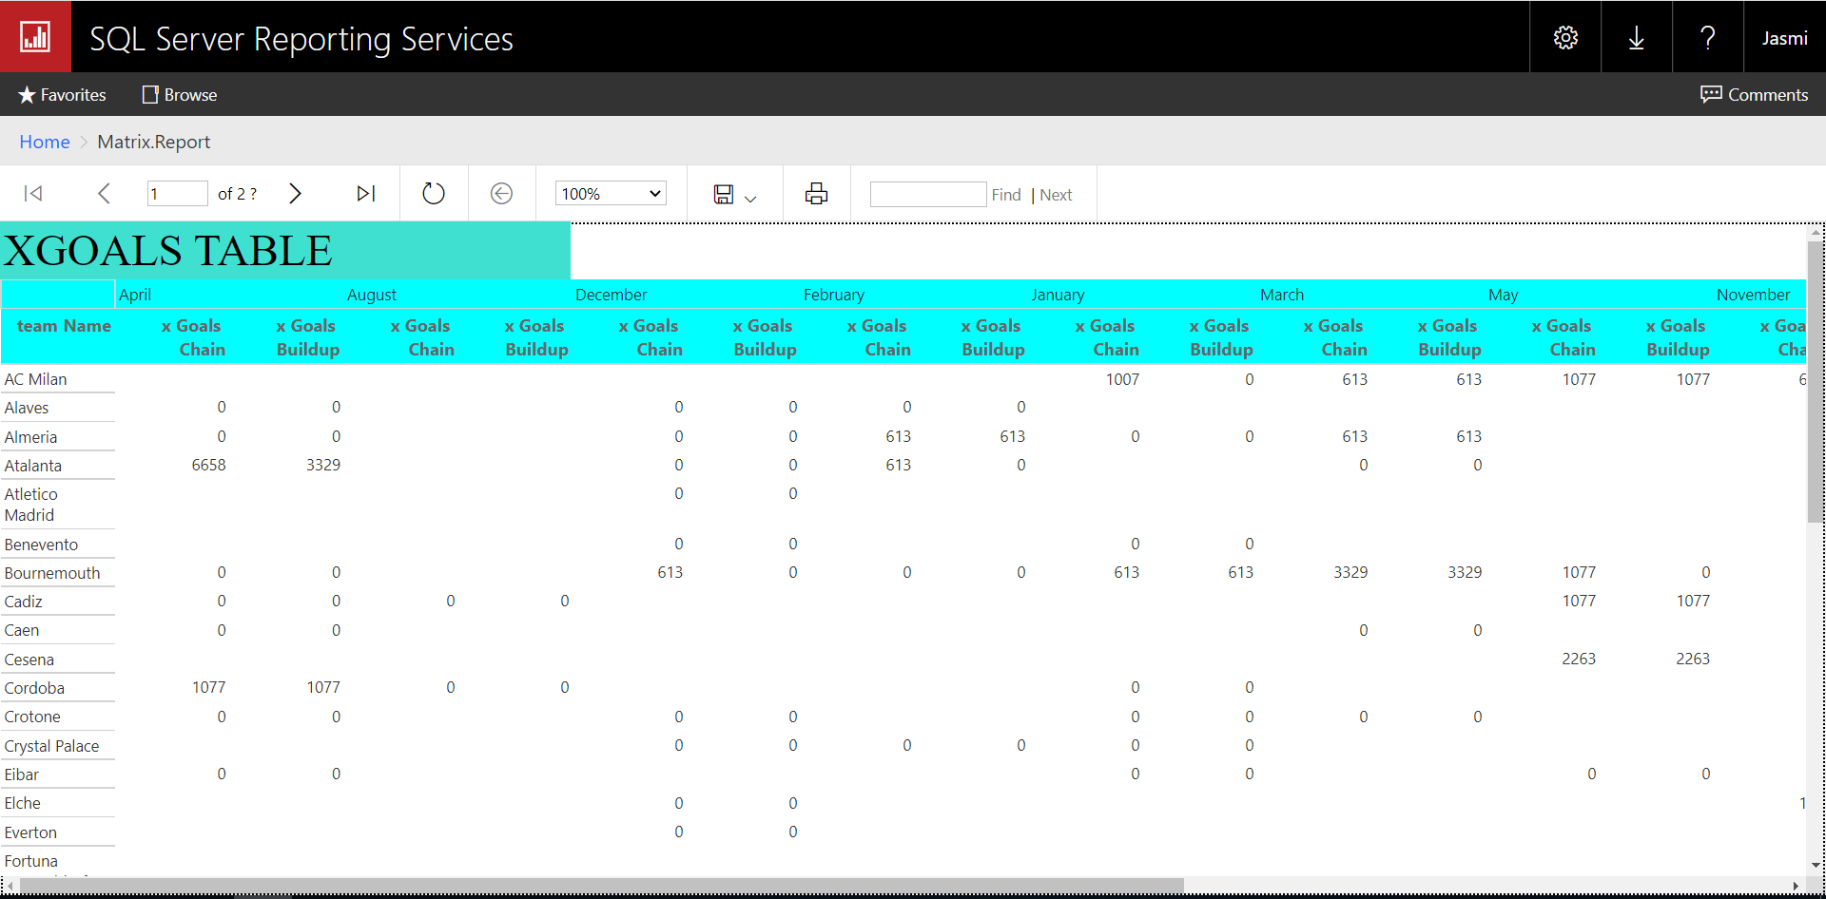Below report shows month wise expected goals chain and expected goals build up according to team name. And the pie chart shows month wise xGoals percentages.

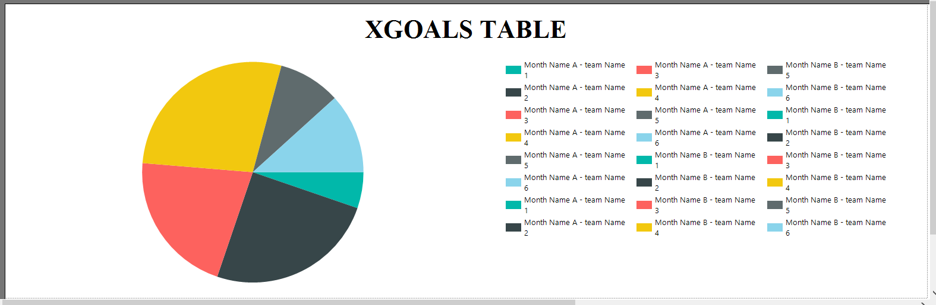

1. **Report 2 : Report with more than one parameter**

This is the structure of the SSRS in Report Builder in report with more than one parameter. My SSRS project is named as Multiple-parameters.Report and the created report can be seen as the figure.

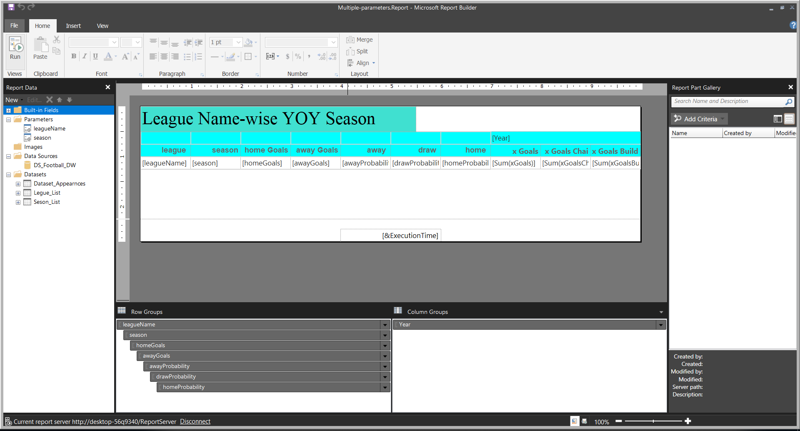

In this report I used two parameters of league name and season. And multiple options can be selected in the parameter.

Then, it can be can selected values from league name drop down and season drop down and then relevant details related to parameter values is displayed.

Below figures shows two parameters and the result reports of them.

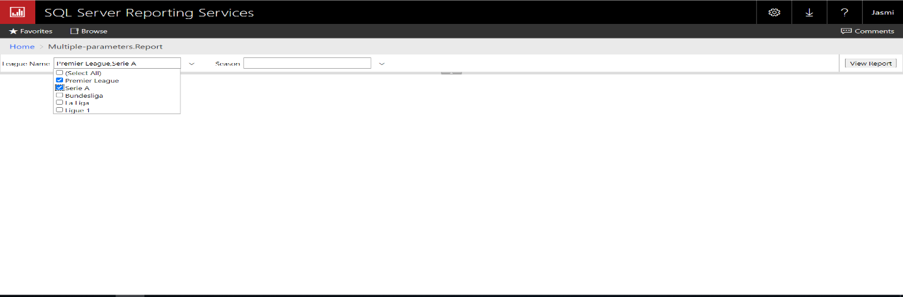

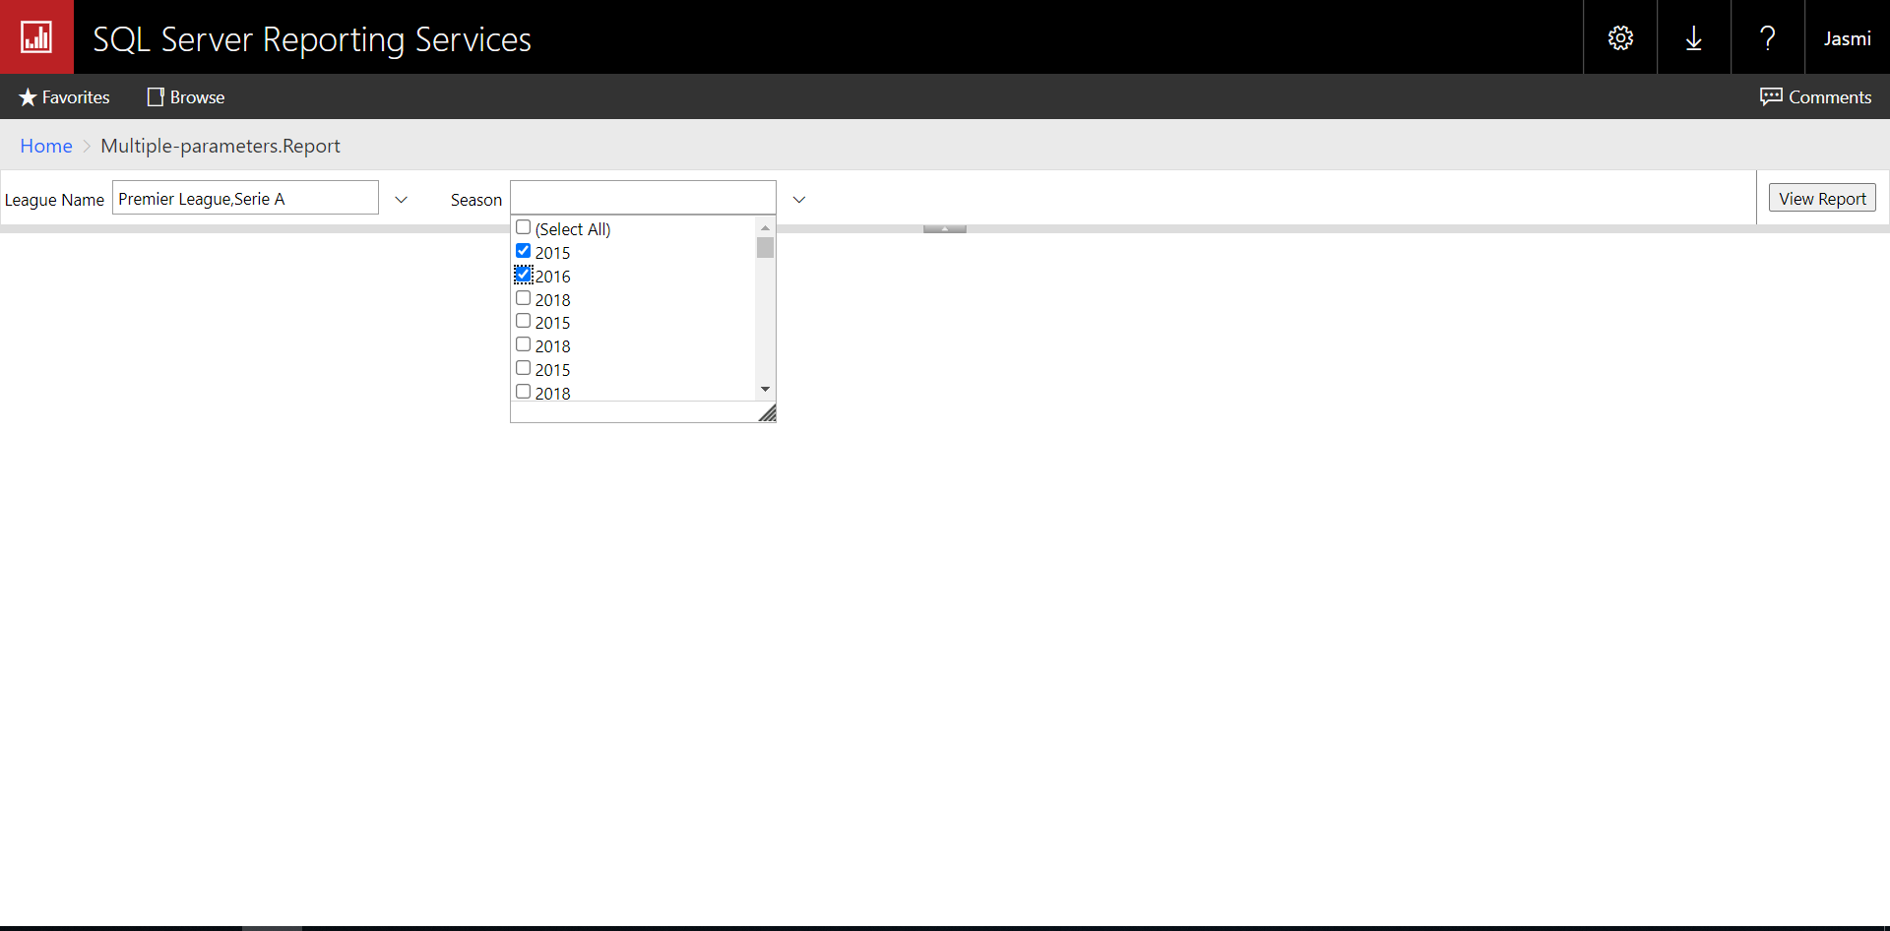

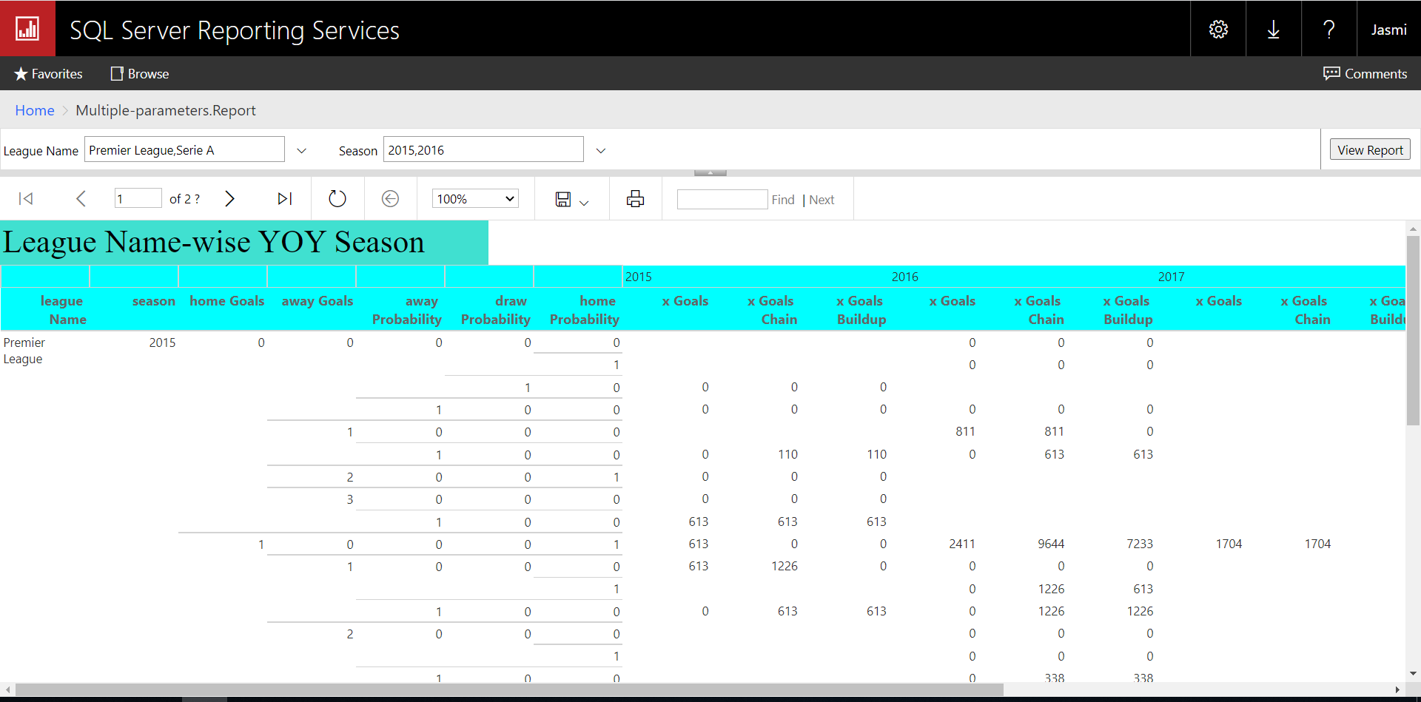

1. **Report 3: Create an SSRS drill-down report.**

This is the structure of the SSRS in Report Builder in drill-down report. My SSRS project is named as DrillDown.Report and the created report can be seen as the figure.

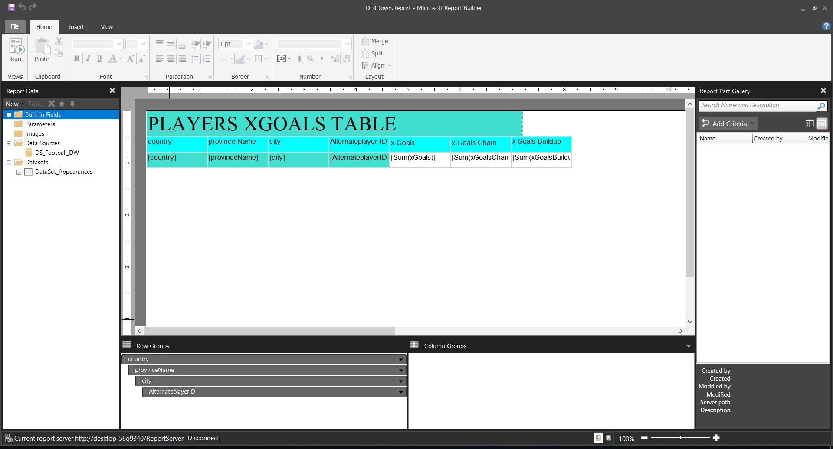

Drill Down Reports allow users to Show or Hide Column Data by using plus and minus symbols.

In here we can view players’ address details are hidden by providing a plus sign. It can be expanded by clicking plus sign to see other hidden fields. In this table, we can find a particular xGoals, xGoals chain and xGoals buildup of the player by clicking the relevant country and dropping down the correct information from the hierarchy.

In the bar chart shows city wise xGoals, xGoals chain and xGoals buildup count.

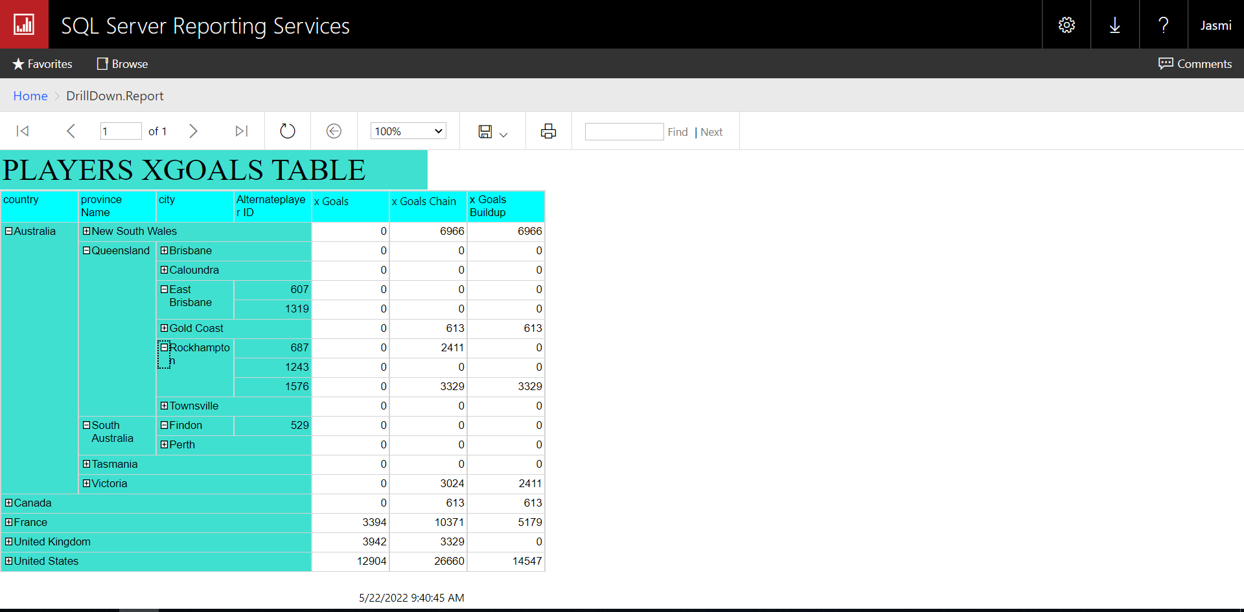

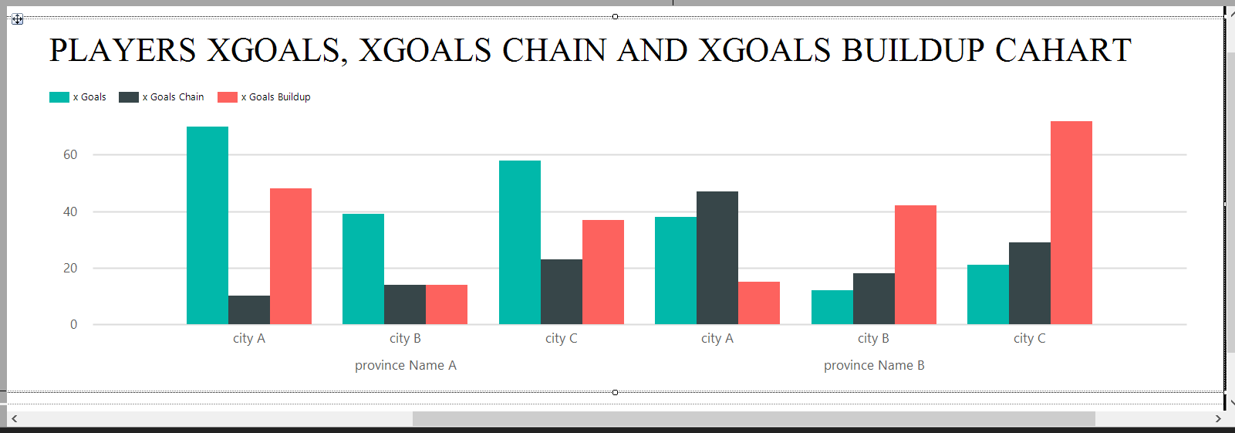

1. **Report 4 : Create an SSRS drill-through report**

This is the structure of the SSRS in Report Builder in drill-through report. My SSRS project is named as Drill-Through.Report and Drill-Through.Report-L2 the created report can be seen as the figure.

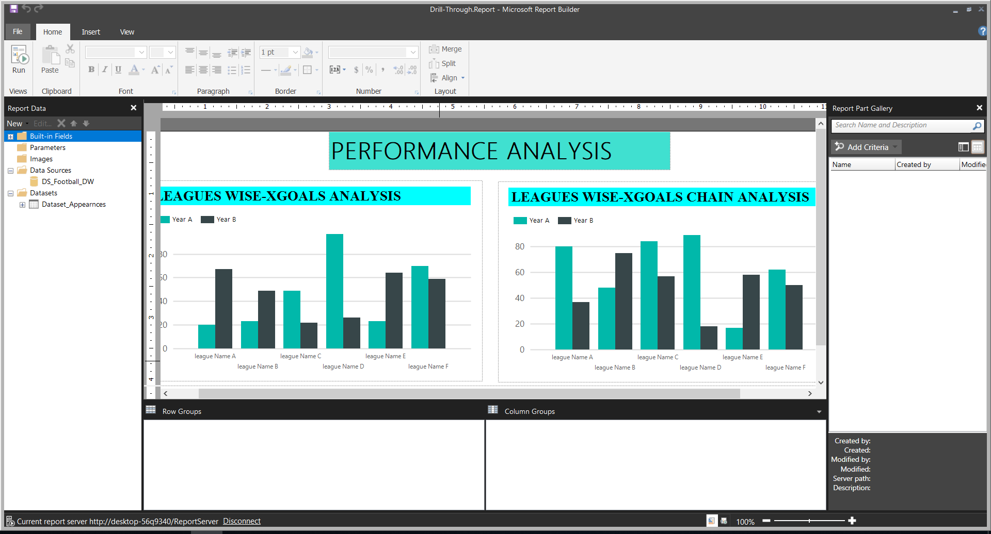

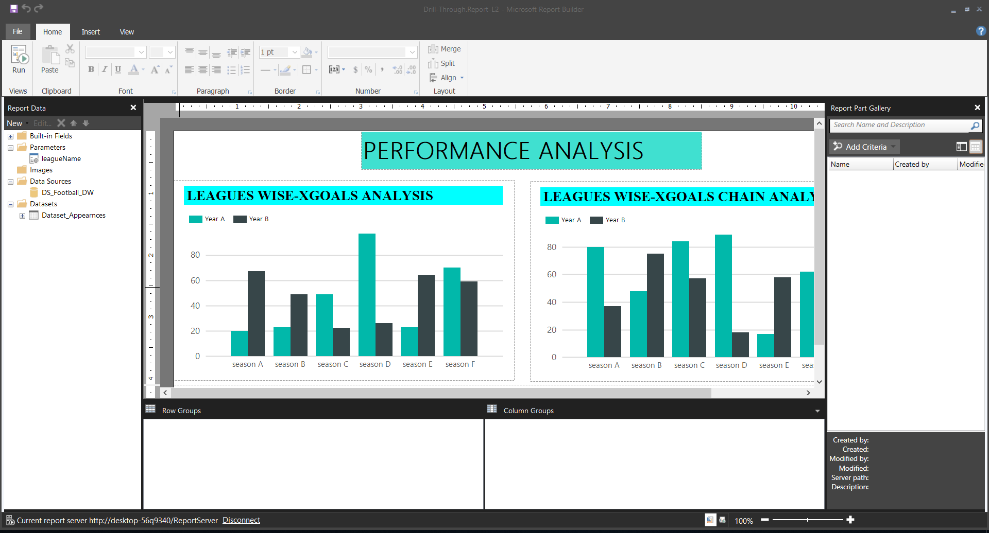

A drill-through report is one that a user accesses by following a link from another report.

Drilling down through a report opens a new window with an entirely different visualization or report. In this report is visualized leagues wise xgoals and leagues wise xgaols chain.

Below figures shows that graphs and detailed reports of league wise xgoals and league wise xgoals chain.

